Anna Calderon

Harvard Forest

gDistance Notes

27 June 2016

Raster Layers

What is raster data? In its simplest form, a raster consists of a matrix of cells (or pixels) organized into rows and columns (or a grid), as shown in the graphic below, where each cell contains a value representing information, such as temperature.  Rasters are digital aerial photographs, imagery from

­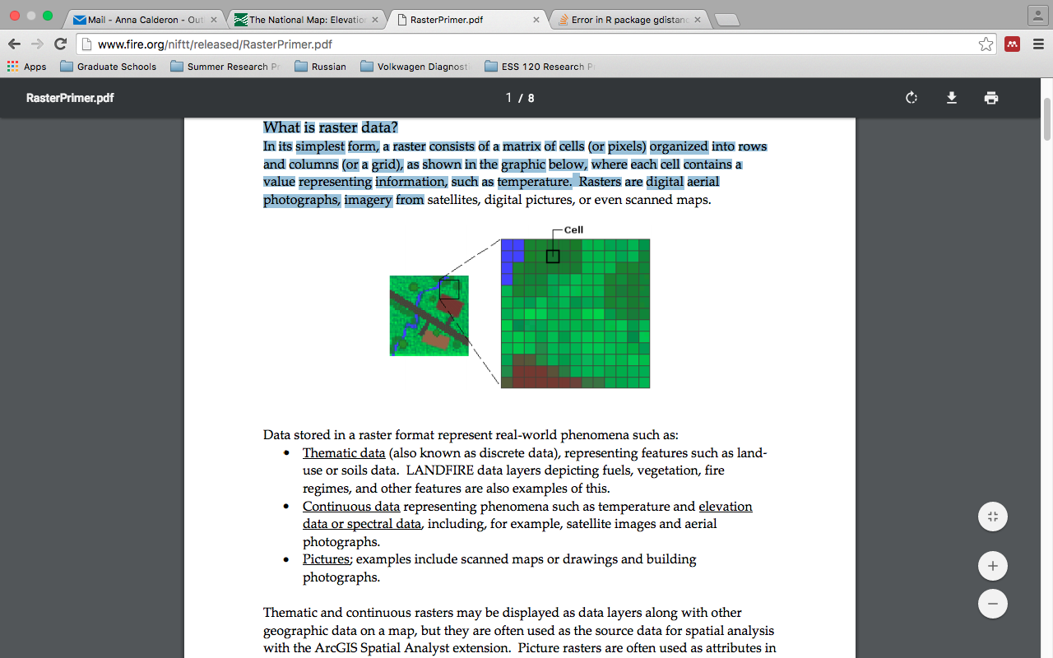

Create a Transition object from a RasterLayer or RasterBrick object. Transition values are calculated with a user-defined function from the grid values.

install.packages("gdistance")

install.packages('FedData')

library("gdistance")

library(FedData)

vepPolygon <- polygon_from_extent(raster::extent(672800,740000,4102000,4170000),proj4string="+proj=utm +datum=NAD83 +zone=12")

NED <- get_ned(template=vepPolygon,label="VEPIIN")

NED <- projectRaster(NED,crs="+proj=utm +datum=NAD83 +zone=12")

set.seed(123)

r <- NED

altDiff <- function(x){x[2] - x[1]}

hd <- transition(r, altDiff, 8, symm=FALSE)

slope <- geoCorrection(hd)

adj <- adjacent(r, cells=1:ncell(r), pairs=TRUE, directions=8)

speed <- slope

speed[adj] <- 6 * exp(-3.5 * abs(slope[adj] + 0.05))

Conductance <- geoCorrection(speed)

## Retrieve a Conductance matrix:DDDDD

#Conductance[1:3, 1:3]

image(Conductance[1:500, 1:500]) #I think darker numbers equal highest conductance

#defining two points on the graph

A <- c(672800, 4102000)

B <- c(673000, 4103000)

AtoB <- shortestPath(Conductance, A, B, output="SpatialLines")

BtoA <- shortestPath(Conductance, B, A, output="SpatialLines")

plot(r, xlab="x coordinate (m)", ylab="y coordinate (m)",

legend.lab="Altitude (masl)")

lines(AtoB, col="red", lwd=2)

lines(BtoA, col="blue")

text(A[1] - 10, A[2] - 10, "A")

text(B[1] + 10, B[2] + 10, "B")

#Calculating Distances

#sP <- cbind(c(,), c(,))

#costDistance(Conductance, sP)

#rSPDistance(Conductance, sP, sP, theta=1e-12, totalNet = "total")